1. Create a webpage that prints your name to the screen.

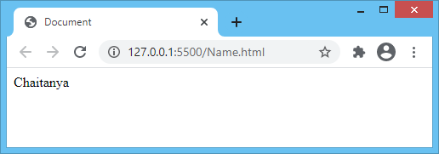<html lang="en">

<head>

<title>Document</title>

</head>

<body>

<p>Chaitanya</p>

</body>

</html>

2.Create a webpage that prints the numbers 1 - 10 to the screen.

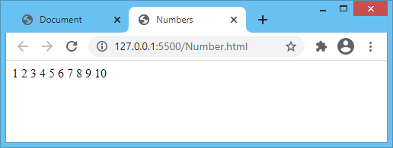<html lang="en">

<head>

<title>Numbers</title>

</head>

<body>

1 2 3 4 5 6 7 8 9 10

</body>

</html>

3.Print a paragraph with 4 - 5 sentences. Each sentence should be a different font.

<html lang="en">

<head>

<title>Document</title>

</head>

<body>

<p>

<font face="tahoma">Paragraphs are building blocks of papers.</font><br/>

<font face="serif"

>Many students define paragraphs interms of length.</font

><br />

<font face="arial">A paragraph is a group of atleast four sentences.</font

><br />

<font face="Times">Generally a paragraph is half a page long.</font>

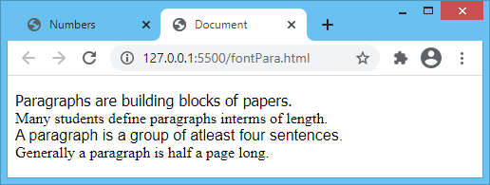 </p>

</body>

</html>

4. Print a paragraph that is a description of a book, include the title of the book as well as its author. Names and titles should be underlined, adjectives should be italicized and bolded.

<html lang="en">

<head>

<title>Document</title>

</head>

<body>

<p>

The author of the BOOK <u>DEEP WORK </u> , <u>Cal Newport</u>

writes about how professionals of today have started valuing

<b><i>quantity</i></b> over <b><i>quality</i></b>.

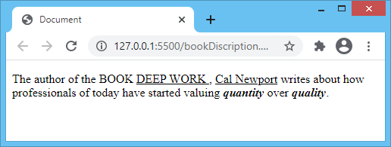 </p>

</body>

</html>

5.Print your name to the screen with every letter being a different heading size.

<html lang="en">

<head>

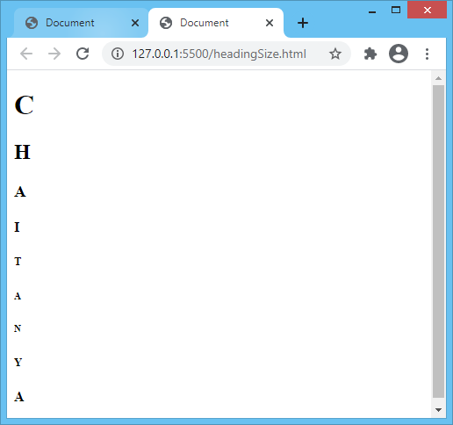 <title>Document</title>

</head>

<body>

<h1>C</h1>

<h2>H</h2>

<h3>A</h3>

<h4>I</h4>

<h5>T</h5>

<h6>A</h6>

<h6>N</h6>

<h5>Y</h5>

<h4>A</h4>

</body>

</html>